SECTION 03300 - CAST-IN-PLACE CONCRETE
- GENERAL
      - RELATED DOCUMENTS
        - Drawings and general provisions of the Contract, including General and Supplementary Conditions and Division 1 Specification Sections, apply to this Section. Refer to the current version of the following:
        - ACI 301, Specifications for Structural Concrete
        - ACI 302, Guide for Concrete Floor and Slab Construction
        - ACI 305, Hot Weather Concreting
        - ACI 306, Cold Weather Concreting
        - ACI 360, Design of Slabs on Ground
        - ASTM A 82, Standard Specification for Steel Wire, Plain, for Concrete Reinforcement
        - ASTM A 185, Standard Specification for Steel Welded Wire Reinforcement, Plain, for Concrete
        - ASTM A 496, Standard Specification for Steel Wire, Deformed, for Concrete Reinforcement
        - ASTM A 497, Standard Specification for Steel Welded Wire Reinforcement, Deformed, for Concrete
        - ASTM A 615, Standard Specification for Deformed and Plain Billet-Steel Bars for Concrete Reinforcement
        - ASTM C 33, Standard Specifications for Concrete Aggregates
        - ASTM C 94, Standard Specifications for Ready Mixed Concrete
        - ASTM C 150, Standard Specification for Portland Cement
        - ASTM C 260, Standard Specification for Air Entraining Concrete
        - ASTM C 494, Standard Specification for Chemical Admixtures for Concrete.
        - ASTM C 618, Coal Fly Ash and Raw or Calcined Natural Pozzolan for Use as a Mineral Admixture in Concrete
        - ASTM C 1107, Standard Specification for Packaged Dry, Hydraulic-Cement Grout (Non-shrink)
        - ASTM C 1315, Standard Specification for Liquid Membrane-Forming Compounds Having Special Properties for Curing and Sealing Concrete
        - ASTM D 448, Standard Classification for Sizes of Aggregate for Road and Bridge Construction
        - ASTM D 1556, Standard Test Method for Density and Unit Weight of Soil in Place by the Sand-Cone Method
        - ASTM D 1557, Standard Test Methods for Laboratory Compaction Characteristics of Soil Using Modified Effort (56,000 ft-lb/ft³)
        - ASTM D 1751, Standard Specification for Preformed Expansion Joint Filler for Concrete Paving and Structural Construction (Non-extruding and Resilient Bituminous Types)
        - ASTM D 2167, Standard Test Method for Density and Unit Weight of Soil in Place by the Rubber Balloon Method
        - ASTM D 2922, Standard Test Methods for Density of Soil and Soil-Aggregate in Place by Nuclear Methods (Shallow Depth)
        - ASTM E 1155, Standard Test Method for Determining F_{F} Floor Flatness and F_{L} Floor Levelness
        - ASTM E 1643, Standard Practice for Installation of Water Vapor Retarders Used in Contact with Earth or Granular Fill under Concrete Slabs
        - ASTM E 1745, Standard Specification for Water Vapor Retarders Used in Contact with Soil or Granular Fill under Concrete Slabs
      - SUMMARY
        - This Section refers to cast-in-place concrete, including reinforcement, concrete materials, concrete mix(s), placement procedures, finishes and pre-packaged grout.
        - See Section 02751 "Concrete Pavement, Curb and Sidewalk" for all concrete other than building.
        - See Section 02300 “Earthwork” for fill under slabs-on-grade.
        - See Section 03470 “Tilt-Up Pre-cast Concrete” (if indicated on drawings).
        - The General Contractor shall furnish all labor, materials, and equipment necessary to complete all concrete work shown or required by the drawings or specified herein. This shall include but is not limited to, all footings, slabs, beams, retaining walls, piers, formwork, metal accessories, expansion joints, cement finishes and all work directly related to concrete work, to include compacted stone base if, and as directed, by the General Contractor.

        - Furnish and install all reinforcing bars, dowels, mesh, ties, etc., as noted and required for all reinforced concrete work as shown.

      - DEFINITIONS
        - Cementitious Materials: Portland cement alone or in combination with one or more of the following: blended hydraulic cement, fly ash, slag cement, other pozzolans, and silica fume; materials subject to compliance with requirements.
        - W/C Ratio: The ratio by weight of water to cementitious materials.
      - SUBMITTALS
        - All submittals are to be made on Site Folio (www.sitefolio.net)
        - Product Data: For each manufactured material and product indicated.
        - Concrete Mix(s):
          - The Lowe’s Companies Concrete Mix Submittal Form is provided at the end of this section.
          - The General Contractor shall submit copies of the completed Concrete Mix Submittal Form 10 days prior to the Pre-Concrete Conference to the following:
            - Lowe’s: Representative
            - Euclid Chemical: Phil Brandt, pbrandt@euclidchemical.com
          - Required Attachments:
            - Compressive Strength Data or Trial Mixture Test Data
            - Cement Data, including Test Reports, Mill Certifications, and Supplier’s Quality Assurance.
            - Fly Ash Data, including Test Reports, Mill Certifications, and Supplier’s Quality Assurance.
            - Coarse and Fine Aggregate Gradation Report
            - Admixture Compatibility Certification Letter
          - Submit items listed in ACI 301.
        - Shop Drawings: Details of steel reinforcement placement including material, grade, bar schedules, stirrup spacing, bent bar diagrams, arrangement, and supports shall be submitted on Site Folio (www.sitefolio.net).
        - Material certificates and test reports.
        - The General Contractor and Concrete Sub-Contractor shall execute the provided “Conformance Submittals” for the specified curing compound, liquid densifier/sealer, and joint filler. NO SUBSTITUTIONS ARE ALLOWED.
      - QUALITY ASSURANCE
        - Ready Mix Concrete Producer Qualifications: A firm experienced in producing ready-mixed concrete that complies with ASTM C 94 requirements for production facilities and equipment. Comply with ACI 301, “Specification for Structural Concrete,” unless modified by the requirements of the Contract Documents.
          - Ready Mix Concrete Producer shall be certified to NRMCA’s “Certification of Ready Mixed Concrete Production Facilities.” Certification shall not be more than twelve months old.
        - Testing Agency Qualifications: An independent agency, qualified according to ASTM C 1077 and ASTM E 329 for testing indicated, as documented according to ASTM E 548.
          - Personnel conducting field tests shall be qualified as ACI Concrete Field-Testing Technician, Grade 1, according to ACI CP-01 or an equivalent certification program.
          - Personnel performing laboratory tests shall be ACI-certified Concrete Strength Testing Technician and Concrete Laboratory Testing Technician - Grade I. Testing Agency laboratory supervisor shall be an ACI-certified Concrete Laboratory Testing Technician - Grade II.
          - Concrete Testing Agency Technician shall visit the ready-mix plant one day prior to each scheduled placement and visually verify that sufficient aggregate and sand to complete the next day’s placement is present and adequately protected from weather.
        - Concrete Sub-Contractor Qualification: The Concrete Sub-Contractor crew responsible for placing and finishing concrete for the interior sales floor and exterior garden center slabs on ground shall include a minimum of three (3) crewmembers that are certified by the American Concrete Institute as Concrete Flatwork Finishers, or by the American Society of Concrete Contractors. Concrete Sub-Contractor shall include in their bid package to the General Contractor, their certification numbers, sufficient proof of certification and at least three successful references of equal size and scope. The submittal shall clearly indicate the Concrete Sub-Contractor’s ability to successfully perform the work and to achieve the floor slab tolerances specified herein. The Concrete Sub-Contractor’s crew proposed for the work specified herein shall have participated in most of the referenced projects, and that crew foreman and crew shall remain the same for every placement of concrete through the duration of this project.
D. Trained Applicator Qualification: All General Contractors bidding or negotiating a Lowe’s project shall contact Euclid Chemical to obtain a list of Trained Applicators located within the geographic region of the project. General Contractors shall solicit and accept pricing only from Trained Applicators as included in the Manufacturer’s list. The Trained Applicator selected for joint filling and initial application of liquid densifier/sealer shall be the same as for the polishing process and additional application of liquid densifier/sealer specified herein.
        - Pre-Concrete Floor Slab Conference: At least 30 days prior to the start of interior sales floor slab construction, the General Contractor shall conduct a meeting at the project site to review all aspects of concrete placement. The General Contractor shall send a pre-concrete conference agenda (at the end of this section), including proposed concrete mix(s) to all attendees 10 days prior to the scheduled date of the conference.
          - The General Contractor shall require responsible representatives of every party concerned with the concrete work to attend the conference, including but not limited to the following:
            - General Contractor: Project Manager and Project Superintendent
            - Testing Agency responsible for concrete mix(s)
            - Testing Agency responsible for field quality control
            - Concrete Sub-Contractor (Crew Foreman)
            - Subgrade Sub-Contractor
            - Ready-mix Concrete Producer
            - Admixture Manufacturer
            - Liquid Densifier/Sealer and Joint Filler Manufacturer
            - Trained Applicator for Liquid Densifier/Sealer, Polishing and Joint Filling
            - Lowe’s Representative
            - Phil Brandt, pbrandt@euclidchemical.com
          - Pre-Concrete Floor Slab Conference Minutes:
            - Within five days of the meeting, minutes of the meeting shall be recorded, typed, and distributed by the General Contractor to all concerned parties, including the Lowe’s Representative, the Architect, and the Engineer.
            - Minutes shall include a statement by the Ready-Mix Concrete Producer stating that the proposed concrete mix(s) will produce the concrete quality specified herein.
            - Minutes shall also include a statement by the Concrete Sub-Contractor that the proposed concrete mix(s) will provide appropriate workability and setting times, to ensure Concrete Sub-Contractor can achieve the requirements specified herein.
        - Interior Sales Floor Test Slab: Following the Pre-Concrete Floor Slab Conference, the Concrete Sub-Contractor shall construct a test slab using the same equipment, tools and methods for finishing and curing the test slab as will be used for the remaining interior floor slab. The test slab shall be the entire interior slab area of Shipping and Receiving, as indicated on drawings, to ensure that the same personnel, materials, methods and equipment for placing and finishing the concrete, including application of liquid densifier/sealer and polishing process, and joint filling will be utilized and applied to the test slab as will be for the remainder of the interior floor slab. Interior sales floor slab construction and concrete placements shall not commence until the Lowe’s Representative has accepted the interior sales floor test slab.
- PRODUCTS
      - MATERIALS
        - Formwork: Furnish formwork and form accessories according to ACI 301.
        - Reinforcement:
          - Reinforcing Bars (if indicated on drawings): Shall conform to ASTM A 615/A 615M, Grade 60, medium grade. All bars shall be deformed and shall be free of rust or other matter, which would affect its bonding properties.
          - Alternate: Reinforcement in Slab or retaining walls (if indicated on drawings): Deformed-Steel Structural welded wire reinforcement (S.W.W.R.) shall conform to ASTM A496 and ASTM A497. The Structural Engineer of record must approve the substitution of S.W.W.R. for rebar.
          - Steel Welded Wire Fabric (S.W.W.F.) (if indicated on drawings): ASTM A82 shall conform to “Specifications for Welded Wire Fabric for Concrete Reinforcement” (ASTM A185).
          - Flat Plate Doweling Systems: Shall be in accordance with ACI 302.
            - “Speed Plate” by Green Streak Group.
            - “Diamond Dowel” by PNA.
        - Concrete Materials:
          - Portland Cement: ASTM C 150/C150M, Gray Color, Type I, Type II, Type I/II, Type III, Type V.
          - Blended Hydraulic Cement: ASTM C 595/C595M, Type IL, Portland-limestone cement.
            - Use one brand of cement throughout the project.
          - Fly Ash: Shall conform to the requirements of ASTM C618. Class F or C per ASTM C 618, except loss on ignition to be 3% maximum. To mitigate potential aggregate reactivity, fly ash is to have the following properties.

a. Maximum 1.5% available alkali.

b. Maximum 8% CaO
          - Coarse and Fine Aggregates: Shall conform to ASTM C 33. Provide aggregates from a single source. Fine aggregate shall have a fineness modulus range of 2.5 to 3.0. Combined aggregate gradation for interior floor slab and other designated concrete shall be 8% - 18% for large top size aggregates (1½”) or 8% - 22% for smaller top size aggregates (1” or ¾”) retained on each sieve below the top size and above the No. 100 sieve. Maximum aggregate sizes shall be:
- 1½" for slabs on grade
- 1" for footings and piers
- ¾" for beams
          - Stockpiles of coarse aggregate shall be built in horizontal layers to avoid segregation and shall be stored separately and in such a manner to be free of intrusions of foreign materials.
          - Water: ASTM C 94 and potable. Mixing water shall be clear and apparently clean. Do not use wash out water from mixer washout operations or recycled water.
        - Admixtures:
          - Air-Entraining Admixtures: Shall conform to ASTM C-260. Air-Entraining admixtures are only allowed in exterior ABOVE ground applications. All exterior concrete slabs shall be air-entrained (6% +/- 1%). Air-Entraining admixtures are NOT allowed for interior slabs, below ground footings, etc. Admixture manufacturer shall provide written certification that the air-entraining admixture is compatible with other required admixtures. Use one of the admixtures listed below.
            - “AEA-92” or “Air 40” by Euclid Chemical.
            - “Micro Air” by Master Builders Solutions.
            - “Sika AIR” or “Sika AEA” by Sika.
            - “Daravair 1000” or “Darex-II” by GCP Applied Technologies.
          - Water Reducing Admixture: Shall conform to ASTM C-494, Type A or Type F. Unless otherwise permitted, use one of the admixtures listed below:
            - “Eucon” Series by Euclid Chemical.
            - “Pozzolith” Series by Master Builders Solutions.
            - “Sikaplast 500” or “Sikament” Series by Sika.
            - “WRDA” or “Daracem” Series by GCP Applied Technologies.
          - Water Reducing, Retarding Admixture: Shall conform to ASTM C-494, Type D. Unless otherwise permitted, use one of the admixtures listed below:
            - “Retarder Series” by Euclid Chemical.
            - “Pozzolith” Series or “Delvo” by Master Builders Solutions.
            - “Plastiment” Series by Sika.
            - “Daratard 17” by GCP Applied Technologies.
          - High Range Water-Reducing Admixture (Superplasticizer): Shall conform to ASTM C-494, Type F or Type G. Use one of the admixtures listed below:
            - “Eucon 37” or “Plastol 341” or “Plastol 5000” by Euclid Chemical.
            - “Rheobuild 1000” or “Glenium” Series by Master Builders Solutions.
            - “Sikament” or “ViscoCrete” Series by Sika.
            - “Daracem-100” or “Adva Flow” by GCP Applied Technologies.
          - Water Reducing, Non-Corrosive Accelerating Admixture: Shall conform to ASTM C-494, Type C or Type E. Unless otherwise permitted, use one of the admixtures listed below:
            - “Accelguard 80,” “Accelguard 90” or “Accelguard NCA” by Euclid Chemical.
            - “NC534” or “Pozzutec 20” by Master Builders Solutions.
            - “Sikaset NC” or “Plastocrete 161FL” by Sika.
            - “Polarset” by GCP Applied Technologies.
          - Integral Finishing Admixture: Integral finishing admixture that reduces rapid moisture loss from concrete surface by binding the internal water in the pore structure, especially effective when concreting operations must be performed in direct sun, wind, high temperatures, or low relative humidity. Integral Finishing Admixture shall also be used to reduce excessive bleeding and segregation of concrete or mortar and shall contain no added chlorides or chemicals known to promote the corrosion of steel. Integral Finishing Admixture shall be compatible with most other admixtures commonly used in concrete including air entraining admixtures, Polycarboxylate-based HRWR admixtures (super plasticizers), conventional water reducing admixtures, and retarders.

a. Acceptable product: Euclid Chemical “EucoShield.”
          - Alkali Silica Reactivity (ASR) Control Admixture: Lithium nitrate admixture for the prevention of ASR in concrete when reactive aggregate, sufficient alkalis and moisture are present. Admixture must have test data indicating conformance to ASTM C1293 and should be used in conjunction with a “Type F Fly Ash.”
            - “Eucon Integral Arc,” by Euclid Chemical.
          - PROHIBITED ADMIXTURES:
            - Calcium chloride or admixtures containing more than 0.05% chloride ions are not permitted.
          - Certification: Written conformance to the above-mentioned requirements and the chloride ion content of admixtures will be required from the admixture manufacturer prior to mix design review by the Engineer or other entity as designated by Lowe’s.
        - Base Material: Base material shall be a clean, densely-graded, granular material with a balanced fine content. It shall produce an easily constructed, low-friction surface while minimizing wicking of moisture from below. These densely-graded crushed products are commonly referred to as “crusher-run” materials. Base material shall be like the following: 100% passing the 1½" sieve, 15% to 55% passing the No. 4 sieve, and less than 12% passing the No. 200 sieve.
        - Vapor Retarder (if indicated on drawings): Shall be polyethylene sheet conforming to ASTM E1745; Class A, not less than 10mils thick.
        - Joint-Filler Strips: Shall Conform to ASTM D 1751, asphalt-saturated cellulosic fiber.
        - Evaporation Retarder: Spray-applied, waterborne, monomolecular film, to aid in the prevention of rapid moisture loss from fresh concrete surfaces during the finishing operations.
          - “Eucobar” by Euclid Chemical
        - Curing:
          - Interior Curing (Choose One):
            - Moisture Retaining Cover: The interior sales floor slab shall be protected from premature drying for a minimum of five days, as required in ACI 301, using moisture-retaining cover. Single use moisture retaining cover from a previous project shall not be reused for any portion of the interior sales floor slab. Subject to project requirements provide one of the following products:
              - “HydraCure S16 (Single Use)” by PNA Construction Technologies.

2. “Transguard 4000” by REEF Industries.

b. Spray Applied: The interior sales floor slab shall be cured using a reduced odor, dissipating liquid membrane forming curing compound that is formulated from hydrocarbon resins. The dissipating liquid membrane forming curing compound shall meet the requirements of ASTM C-309 and VOC contents in accordance to EPA 40cfr, part 59, and table 1, subpart D for concrete curing compounds with a maximum VOC content of 350g/l. Subject to project requirements provide one of the following products:

1. “Kurez DR VOX” or “Kurez DR100” by Euclid Chemical.

2. Exterior Curing and Sealing (Choose One):

a. ASTM C1315, Type I, Class B, (700 g/l): Liquid type membrane-forming curing compound, clear styrene acrylate type, complying with ASTM C1315, Type I, Class B, 25% solids content minimum. Moisture loss shall be not more than 0.30 Kg/m² when applied at 300 sq. ft./gal. Manufacturer's certification is required. Subject to project requirements provide one of the following products:

1. "Super Diamond Clear" by Euclid Chemical.

2. "Kure N Seal 30" by Sika.

b. ASTM C1315, Type I, Class A, (350 g/l): Liquid type membrane-forming curing compound, clear styrene acrylate type, complying with ASTM C1315, Type I, Class A, 25% solids content minimum. Moisture loss shall be not more than 0.40 Kg/m² when applied at 300 sq. ft./gal. Manufacturer's certification is required. Subject to project requirements provide one of the following products:

1. "Super Diamond Clear VOX" by Euclid Chemical.

2. "MasterKure CC 300 SB” by Sika.
        - Liquid Densifier/Sealer: Blend of silicate and siliconate polymers that penetrate concrete surfaces and chemically react to provide an increase in surface density, durability, and abrasion resistance. The compound must contain a minimum solids content of 20% of which 50% is siliconate. Subject to project requirements provide the following product:
          - “Euco Diamond Hard” by Euclid Chemical: Phil Brandt, pbrandt@euclidchemical.com
          - Warranty: The General Contractor shall provide the following warranties:
            - Trained Applicator: Shall provide a five (5) year labor warranty for this Lowe’s project.
            - Manufacturer: Shall provide a twenty (20) year product warranty provided by the manufacturer of the liquid densifier/sealer. All invoices for liquid densifier/sealer indicating the purchase and delivery of liquid densifier/sealer to the project site shall be submitted to the liquid densifier/sealer manufacturer for warranty purposes. Furnish the Lowe’s Representative a written warranty signed by an officer of the liquid densifier/sealer manufacturer and written warranty from approved applicator of the liquid densifier/sealer. All warranties shall start at “construction completion” date.
K. Expansion Joint (Column Wrap): Flexible foam expansion joint filler ½" thick. Subject to project requirements provide the following product:
            - “Ceramar” by W.R. Meadows: 800-342-5976
          - Application: Wrap base of columns with appropriate height material to cover top of slab to top of base plate. Product shall be secured to column with sealant as recommended by manufacturer. Additional 4” high wrap shall extend from top of main wrap layer to above slab placement without use of sealant. Exposed portion of additional wrap shall be removed after all floor curing and finishing operations, but prior to painting of columns.
- Semi-Rigid Polyurea Joint Filler: The polyurea joint filler shall be U.V. resistant, two components, and 100% solids compound, with a minimum Shore “A” hardness of 80. Color of joint filler to match adjacent concrete surface. Subject to project requirements provide the following product:
            - “Euco QWIKjoint UVR” by Euclid Chemical.
            - Invoices: Trained Applicator applying the specified joint filler shall provide the manufacturer all joint filler invoices. Invoices are submitted for verification purposes and shall indicate the purchase and delivery of specified joint filler to the Lowe’s project site.
- Exterior Urethane Joint Sealant: ASTM C 920-86, Type S, Grade NS/SL, and Class 25 Industrial gun grade polyurethane sealant shall exhibit a shore “A” hardness of 40 and an elongation of 250%. Subject to project requirements provide the following product:
              - “Eucolastic 1 NS/SL” by Euclid Chemical.
        - Adhesives and Polymer Patching Mortars: The adhesive shall be a three component, pre-portioned water-based epoxy modified Portland cement bonding agent and anti-corrosion coating. Subject to project requirements provide the following product:

1. “Duralprep AC” by Euclid Chemical.

O. Horizontal Patching Mortars: The horizontal patching mortar shall be one-component latex and microsilica modified cementitious mortar designed for use as a floor or deck topping. Subject to project requirements provide one of the following products:

1. “VersaSpeed LS100” by Euclid Chemical.

P. Vertical Patching Mortars: The vertical patching mortar shall be one-component latex and microsilica modified cementitious mortar designed for use as a vertical or overhead patching mortar. Subject to project requirements provide the following product:

1. “EucoRepair V-100” by Euclid Chemical.
        - Non-Shrink, Non-Staining Grout: Shall comply with ASTM C 1107 and shall be furnished where indicated on the drawings. Subject to project requirements provide one of the following products:
          - “Euco NS” by Euclid Chemical.
          - “Masterflow 555” by Sika.
  - CONCRETE MIXES
        - Prepare concrete mixes, complying and proportioned according to ACI 301, for normal-weight concrete determined by either laboratory trial mix or field test data as follows:
          - Compressive Strength:
            - Interior Sales Floor: 4000 psi, with a maximum W/C Ratio of .52, unless otherwise indicated on the drawings.
            - Exterior Concrete: 4000 psi, with a maximum W/C Ratio of .45, unless otherwise indicated on the drawings.
          - Slump: All concrete shall not exceed 5.5" unless otherwise indicated on the drawings.
        - Adjustment to Concrete Mixes: Mix design adjustments may be requested when characteristics of materials, job conditions, weather, test results or other circumstances warrant; at no additional cost, and as accepted by Lowe’s. Laboratory test data for revised concrete mix and strength results shall be submitted to and accepted by Lowe’s before using in work. Both the concrete testing and inspection agency and the Concrete Sub-Contractor shall satisfy themselves that the proposed concrete mix design will produce concrete that will meet the project requirements specified herein. In addition, the General Contractor and Concrete Sub-Contractor shall verify that the workability, finishability and setting times are appropriate for slab installations. Placement shall be made by chute directly from concrete trucks. If pumping of the concrete is contemplated for any special locations, the proportions established above shall not be altered to suit the capabilities of the pumping equipment.

        - Interior Sales Floor: Concrete shall conform to ACI 301 and be designed to meet 4000 psi compressive strength at 28 days. The mix shall be designed at a maximum W/C Ratio of 0.52, contain approximately 12 cubic feet of coarse aggregate (1" top size max.), and the specified water reducing admixture. Concrete shall not be air-entrained and in no case shall the concrete be designed for less than 4000 psi at 28 days. Proposed concrete mix shall be like the following prototype mix:

Materials | Prototype Mix
Cementitious Content | 520 - 564 lbs.
Fly Ash | 20% (Max.)
Coarse Aggregate | 12 Cubic Feet +/- .50
Fine Aggregate | 7 Cubic Feet +/- (Adjust as Necessary)
Water Content | 270 lbs. (520 cementitious) – 293 lbs. (564 cementitious)
Air Content (Entrapped Air Only) | 3.0% (Max.)
Mid-Range Water Reducer (Type A/F) | 3oz. - 10oz./100wt (As Required)
W/cm | 0.52 (Max.)
Final Slump | 5.0" – 6.0" (Max.)

        - Exterior Concrete Garden Center: Concrete shall conform to ACI 301 and be designed to meet 4000 psi compressive strength at 28 days. The mix shall be designed at a maximum W/C Ratio of 0.45, contain approximately 12 cubic feet of coarse aggregate (1" top size max.), and the specified water reducing admixture. Concrete shall be air-entrained and in no case shall the concrete be designed for less than 4000 psi at 28 days. Proposed concrete mix shall be like the following prototype mix:

Materials | Prototype Mix
Cementitious Content | 600 - 658lbs.
Fly Ash | 25% (Max.)
Coarse Aggregate | 12 Cubic Feet +/- .50
Fine Aggregate | 7 Cubic Feet +/- (Adjust as Necessary)
Water Content | 270 lbs. (600 cementitious) – 296 lbs. (658 cementitious)
Air Content (Air Entrainment) | 6.0% +/- 1%
Mid-Range Water Reducer (Type A/F) | 3oz. - 10oz./100wt +/-
W/cm | 0.45 (Max.)
Final Slump | 5.0" – 6.0" (Max.)

2.03 CONCRETE MIXING
        - Ready-Mixed Concrete: Comply with ASTM C 94. Ready Mix Concrete operations shall meet DOT approval. All mixers shall be in proper operating condition and the drum fins clean of residue.
          - When air temperature is between 85° and 90°F, reduce mixing and delivery time from 1½ hours to 75 minutes; when air temperature is above 90°F, and reduce mixing and delivery time to 60 minutes.
          - Project-Site Mixing: Measure, batch, and mix concrete materials and concrete according to ASTM C 94. Mix concrete materials in appropriate drum-type batch machine mixer.
        - Batch Tickets: Provide batch ticket for each batch discharged and used in the work, indicating project identification name and number, date, mix type, mix time, quantity, and amount of water added. The batch ticket shall state the quantity of water that may be added at the jobsite without violating the submitted mix design criteria, including W/C Ratio. Record approximate location of final deposit in structure. Concrete Laboratory Testing Technician shall be responsible for collecting batch tickets and recording the location of load placement to the associated batch ticket.
      - CONCRETE TESTING
        - Concrete Tests: Testing of composite samples of fresh concrete obtained according to ASTM C 172 shall be performed according to the following requirements:
          - Testing Frequency: Obtain one composite sample from each day's placement of each concrete mixture exceeding 5 cubic yards, but less than 25 cubic yards, plus one set for each additional 50 cubic yards, or fraction thereof.
          - Water Content and Slump: Test slump in accordance with ASTM C 143; one test at point of placement for each composite sample, but not less than one test for each day's placement of each concrete mixture. Perform additional tests when concrete consistency appears to change.
          - Air Content: ASTM C 231, pressure method, for normal-weight concrete; one test at the beginning of each placement, plus one test for each additional 50 cubic yards, or fraction thereof. Any non-air entrained concrete having air content greater than 3% shall be rejected.
          - Concrete Temperature: ASTM C 1064; one test hourly when air temperature is 40°F and below and when 80°F and above, and one test for each composite sample.
          - Unit Weight: ASTM C 567, fresh unit weight of Structural lightweight concrete; one test for each composite sample, but not less than one test for each day's placement of each concrete mixture.
            - Compression Test Specimens: ASTM C 31.
            - Cast and laboratory cure two sets of two standard cylinder specimens for each composite sample.
            - Cast and field cure two sets of two standard cylinder specimens for each composite sample.
          - Compressive-Strength Tests: ASTM C 39; test one set of two laboratory-cured specimens at 7 days and one set of two specimens at 28 days.
            - A compressive-strength test shall be the average compressive strength from a set of two specimens obtained from same composite sample and tested at age indicated.
          - When strength of field-cured cylinders is less than 85 percent of companion laboratory-cured cylinders, General Contractor shall evaluate operations and provide corrective procedures for protecting and curing in-place concrete.
          - Strength of each concrete mixture will be satisfactory if every average of any three consecutive compressive-strength tests equals or exceeds specified compressive strength, and no compressive-strength test value falls below specified compressive strength by more than 500 psi.
          - Test results, including air content, shall be reported in writing to Lowe’s, Ready Mix Concrete Producer and General Contractor within 48 hours of testing. Reports of compressive-strength tests shall contain Project identification name and number, date of concrete placement, name of concrete testing and inspecting agency, location of concrete batch in Work, design compressive strength at 28 days, concrete mixture proportions and materials, compressive breaking strength, and type of break for both 7- and 28-day tests.
          - Non-Compliant Test Reports: All test reports indicating non-compliance should be emailed immediately to all parties on the test report distribution list. Copies shall be on different color paper.
          - Nondestructive Testing: Impact hammer, sonoscope, or other nondestructive device may be permitted by Lowe’s, but will not be used as sole basis for approval or rejection of concrete.
          - Additional Tests: Testing and inspecting agency shall make additional tests of concrete when test results indicate that slump, air content, compressive strengths, or other requirements have not been met, as directed by Architect or Engineer. Testing and inspecting agency may conduct tests to determine adequacy of concrete by cored cylinders complying with ASTM C 42, or by other methods as directed by Architect or Engineer.
          - Additional testing and inspecting, at General Contractor's expense, will be performed to determine compliance of replaced or additional work with specified requirements.
          - Correct deficiencies in the Work that test reports and inspections indicate do not comply with the Contract Documents.
- EXECUTION
      - INSTALLATION (GENERAL)
        - Formwork: Design, construct, erect, shore, brace, and maintain formwork according to ACI 301.
          - Wood Form Work – Form all slabs, stairs and other formed concrete with ¾" form plywood. For exposed surfaces use plywood with an undamaged face. Form ties shall be “snap” ties.
        - Vapor Retarder (if indicated on drawings): Install, protect, and repair vapor-retarder sheets according to ASTM E1643; place sheets in position with longest dimension parallel with direction of placement.
          - Vapor retarder for concrete floor slab shall be 10mil (minimum) polyethylene. Seal vapor retarder completely around all pipes and conduits. Inspect vapor retarder thoroughly and repair all punctures and tears immediately prior to placing concrete. All laps shall be 18" (minimum) and sealed with a completely continuous pressure sensitive tape.
        - Steel Reinforcement (if indicated on drawings): Comply with CRSI’s “Manual of Standard Practice” for fabricating, placing, and supporting reinforcement.
          - Do not cut or puncture vapor retarder. Repair damage and reseal vapor retarder before placing concrete.
          - Install all anchors, ties, chairs, and other supports as requested to insure reinforcing is supported at proper locations. All reinforcing shall be wired in place using #16 annealed wire. Wood or clay brick chairs are not acceptable.
          - Welded wire fabric mesh (if indicated on drawings) shall be chaired according to current recommendations from the Wire Reinforcement Institute, lapped a minimum of 6" at side laps and secured with tie wires no more than 4 feet on center.
      - CONCRETE PLACEMENT
        - Carbon Monoxide / Carbon Dioxide Exposure: General Contractor shall be responsible for monitoring interior floor exposure to excessive exhaust gases containing carbon dioxide (CO₂) or carbon monoxide (CO). To minimize potential damage to interior floor during slab placement and curing periods, maximum CO₂ levels shall be 4,500 parts per million and maximum CO levels shall be 15 parts per million at concrete surface within 5 feet of any source of exhaust gases. Unvented combustion heaters shall not be in operation during concrete placement, and equipment inside the building during concrete placement shall be limited to the equipment necessary to place and finish concrete. Only two concrete trucks shall be in the building at any given time, and under no circumstance shall there be any earth moving equipment, dump trucks, grading equipment, or any other motorized equipment in operation until after the interior floor is placed and protected by specified curing method. Carbon Monoxide and Carbon Dioxide shall be checked using an appropriate meter from a company like the following: CEA Instruments: 201-967-5660
        - Comply with requirements in ACI 301 for measuring, mixing, transporting, and placing concrete.
          - Install crushed stone sub-base to the minimum compacted thickness as indicated on the construction documents. Prior to installation, verify proper sub-grade elevations to assure that minimum thickness of stone base can be achieved. Crushed stone shall be compacted to 98% Modified Proctor density in accordance with ASTM D 1557. The in-place density shall be tested for compliance no more than 48 hours prior to concrete placement using ASTM D 1556, ASTM D 2167, or ASTM D 2922. One copy of test results shall be forwarded to the Lowe’s Representative.
          - Cooperate with all other trades. Confer with electrical, mechanical, plumbing, carpenters, steel workers, etc. Ensure that all sleeves, anchor, insert, conduit, floor boxes, pipes, fittings, and other items are installed before placing concrete. Make provisions for door saddles, and thresholds.
          - The General Contractor shall ensure the accuracy, placement, and alignment of all under-slab work. The placement of all boxes shall be square, level, and true in all respects.
          - Concrete shall be mixed and delivered in accordance with the requirements of ASTM C 94.

C. Bar supports for reinforcing steel shall be used in all footings to assure proper mechanical strength. Wood or clay brick chairs are not acceptable.
        - Concrete shall not be placed until the forms, reinforcement and other conditions are complete and until all pipes, conduit, sleeves, thimbles, hangers, anchors, and other work required are properly installed.
        - Form-Release Agent: Coat all removable wood and metal forming with a low VOC compliant, non-staining, concrete form-release agent and allow excess liquid to drain off before forms are placed.
        - Concrete Placement: Place concrete within the minimum temperature range and protect as specified in ACI 301. Place on firm, undisturbed earth or properly compacted fill. Consolidate without segregation, by vibrating. Do not place concrete when temperature is 40°F and falling, or when freezing weather is predicted within 24 hours.
          - Unless otherwise specified, all concrete shall be placed upon clean, damp, smooth surfaces that are free from running water. Subgrade and base shall meet compaction requirements and shall be rut-free. Maximum free fall for concrete is 3 feet. Place at point of use. A vibrator is required for placement of concrete in walls, piers, footings, and turndowns. Concrete shall be consolidated and worked into all corners and angles of the forms and around reinforcement and embedded fixtures in such a manner as to prevent segregation of the coarse aggregate.
          - Type III, high early strength cement, calcium chloride, corrosive accelerators or antifreeze shall not be used.
          - Concrete shall be placed before initial set has occurred and in no event after it has contained its water content for more than 1½ hours.
        - During concrete placement, carefully protect all exposed masonry walls, metal building walls and adjacent concrete by covering with waterproof paper, or by turning up the vapor barrier on the walls a minimum of 36".
        - Water shall only be added at the job site under the direct supervision of the Testing Agency. Water may be added in accordance with ASTM C 94. Do not add more water than is indicated as allowable on the batch ticket. Water added at the job site shall be documented on the batch ticket.
      - FORMED SURFACE FINISHES
        - Rough-Formed Finish: As-cast concrete texture imparted by form-facing material with tie holes and defective areas repaired and patched, and fins and other projections exceeding ¼" in height shall be rubbed down or chipped off.
          - Apply to concrete surfaces not exposed to public view.
        - Smooth-Formed Finish: As-cast concrete texture imparted by form-facing material, arranged in an orderly and symmetrical manner with a minimum of seams. Repair and patch tie holes and defective areas. Completely remove fins and other projections. All exposed concrete walls are to be grouted and hand rubbed.
          - Apply to concrete surfaces exposed to public view or to be covered with a coating or covering material applied directly to concrete, such as waterproofing, damp-proofing, veneer plaster, or painting.
          - Do not apply rubbed finish to smooth-formed finish.
          - Apply smooth-rubbed finish, defined in ACI 301, to smooth-formed finished concrete.
        - Related Unformed Surfaces: At tops of walls, horizontal offsets, and similar unformed surfaces adjacent to formed surfaces, strike off smooth and finish with a texture matching adjacent formed surfaces. Continue final surface treatment of formed surfaces uniformly across adjacent unformed surfaces, unless otherwise indicated.
      - CONCRETE FINISHES
        - General: The interior sales floor shall be divided into a minimum of four (4) equal concrete placements. Shipping and Receiving (Test Slab) shall be placed separately. Concrete shall be placed, screeded, re-straightened, and finished as necessary to meet the F_{F} and F_{L} requirements. Protect adjacent concrete surfaces during placement. Do not allow slurry from finishing operations to adversely affect adjacent surfaces. Finishing at all joints (construction and control), shall be consistent and without aesthetic or finishing issues. Do not wet concrete surfaces during finishing operations.

A well compacted, leveled base material is required. The General Contractor shall follow the recommendations of ACI 302 and ACI 360. After multiple passes of a loaded tandem-axle dump truck or a loaded truck mixer or roller, any depression in the surface deeper than ½" shall be repaired prior to concrete placement. Base material shall be dampened with water just prior to concrete placement.
          - Laser screeds, vibratory screeds, highway straightedges and wood or resinous bull floats shall be used to initiate screeding and floating process to form a uniform and open-textured surface plane before excess moisture or bleed water appears on the surface. A back-up laser screed is required during concrete placement of the interior sales floor slab. Remove excess water before floating operations start. Do not further disturb surfaces before finishing operations start.
            - Highway straightedge operations shall continue before, during and after troweling operations.
            - Trowel Finish: Concrete Sub-Contractor shall wait to apply the troweled finish until after the bleed water has escaped the freshly placed and floated concrete. Apply trowel finish using troweling machines with adjustable blades. All finishing blades shall be in new condition and completely clean of any deleterious materials. The final finish shall be a “hard steel troweled” finish, but without burn marks, and shall meet the specified floor tolerances as specified herein.
            - Protection: Care shall be taken to protect the interior sales floor. Entrances shall include clean floor mats to prevent mud stains and all equipment on the floor shall be diapered to prevent spills. Cutting oils, etc., are not allowed on the sales floor slab at any time during the construction process.
        - Trowel Finish: Apply a hard steel trowel finish to surfaces indicated and to floor and slab surfaces exposed to view, or to be covered with resilient flooring, carpet, ceramic or quarry tile set over a cleavage membrane, paint, or another thin film-finish coating system.
        - Heavy Broom Finish: Garden Center, C.L.C. Vestibule, Main Entry Vestibule, Main Exit Vestibule, Cart Storage, ramps, aprons, and walks.
        - Light Broom Finish: Seasonal Display Area as indicated on the drawings.
      - CONSTRUCTION, ISOLATION AND CONTROL JOINTS
        - General: Joints shall be cut as indicated on Drawings, and as soon as the slab will support the weight of the saw and operator and when cutting action will not tear, abrade, or otherwise damage the concrete surface. Cuts must be made before concrete develops random contraction cracks. Employ enough saws and workers to complete cutting of saw joints within 2 hours after final finish of interior floor slab. After saw cutting, immediately vacuum up and remove all residues completely.
          - Construction Joints:
            - Construction joints shall be true to line with faces perpendicular to surface plane of concrete (refer to drawings), so as not to impair strength or appearance of concrete at locations indicated or as approved by Architect or Engineer.
            - Construction joints in slab on grade shall be butt joints with plate dowels as specified herein. Do not use metal keyways.
          - Isolation Joints: Install joint-filler strips at junctions with slabs-on-grade and vertical surfaces, such as column pedestals, foundation walls, grade beams, and other locations, as indicated.
            - Extend joint fillers full width and depth of joint, terminating flush with finished concrete surface, unless otherwise indicated.
          - Control Joints: Form weakened-plane control joints, sectioning concrete into areas as indicated:
            - All saw cutting shall be accomplished with a “Soff-Cut” saw, by Husqvarna Construction Products (800-288-5040), equipped with a new Soff-Cut color-coded, patented diamond blade and skid plate in new condition. Concrete Sub-Contractor must have documented successful experience in the use of this method prior to this project. Joints shall be cut as soon as the slab supports the weight of the saw and operator and when cutting action will not tear, abrade, or otherwise damage the concrete surface. Cuts must be made before concrete develops random contraction cracks. Using a 1/8" thick blade, cut a minimum of 1/4d into the interior floor slab. Chalk lines (white chalk) and concrete dust shall be completely and immediately removed after cutting operation.
            - Random depth checks shall be performed by the Testing Agency to confirm that the specified depth of cut is made. Any cut(s) found to be less than proper depth shall be re-cut to the proper depth and filled with specified joint filler at the General Contractor’s expense.
          - Radius Joints: Form radius joints after initial floating by grooving and finishing each edge of joint with radius tool to a radius of 1/8". Repeat grooving of contraction joints after applying surface finishes. Eliminate radius tool marks on concrete surfaces.

  - INTERIOR FLOOR SLAB TOLERANCES:
        - General: Slabs shall be measured as soon as control joints are cut and in accordance with ASTM E 1155. Unless otherwise noted on drawings, all interior floor slabs shall be constructed as a single course slab with a minimum of three passes of the trowel machine. Additional slabs shall not be cast until the Lowe’s representative has accepted the measurements from the previous day. Comply with ACI 117, “Specifications for Tolerances for Concrete Construction and Materials.” Lowe’s will conduct flatness and levelness testing utilizing an approved Independent Testing Agency.
          - Unless otherwise noted in the drawings, all interior floor slabs shall be constructed to an overall F_{F} 50/F_{L} 35 with a minimum local value of F_{F} 35/F_{L} 25. The overall area is a Test Section as defined in ASTM E 1155. The minimum local area is the area of a single placement.
          - All floated and broomed surface floors shall achieve an F_{F}20/F_{L}17 tolerance.
          - Acceptance of floor slabs for flatness and levelness
              - If F_{F} or F_{L} for a placement is below the minimum local value, the General Contractor, at the direction of the Lowe’s Representative, will do one of the following:
              - Remove and replace the slab.
              - Remove and replace the panel(s)
      - CONCRETE CURING AND PROTECTION
        - Protection: Protect freshly placed concrete from premature drying and excessive cold or hot temperatures. Comply with ACI 305 for hot-weather protection and ACI 306 for cold-weather protection during placing and curing. For concrete placement during hot, dry and windy conditions, Concrete Sub-Contractor shall use the specified evaporation retarder to maintain moist conditions, which minimizes plastic drying shrinkage cracking at the surface of the freshly placed concrete.
        - Interior Curing and Protection:
          - Moisture Retaining Cover: Curing shall commence immediately following control joint cutting and slab tolerance measurements. Curing process shall remain in place for a minimum of five (5) days. Moisture-retaining cover shall be kept wet and flat against the interior floor during the entire curing cycle. Remove moisture-retaining cover and immediately scrub the entire area with auto-scrubber and neutral pH cleaner. Moisture retaining cover shall not be reused for any portion of the interior sales floor slab.
          - Spray Applied Curing Compound: Curing shall commence immediately following control joint cutting and slab tolerance measurements. Interior floor slabs shall be cured using the specified spray applied curing compound at 400sf/gallon. Spray applied curing compound shall be completely removed from interior floor slabs prior to application of liquid densifier/sealer.
          - Protection: Take the following measures to protect interior sales floor slab:
            - Wrap and/or “diaper” all motorized and hydraulic equipment to prevent fluid leaks.
            - Provide non-marking tires on rubber-tired vehicles or equip rubber tires with tire boots made of nylon fabric.
            - The General Contractor shall remove, to the satisfaction of the Lowe’s Representative, all stains and debris from the interior slab on ground.
        - Exterior Curing and Protection:
          - Exterior concrete slabs shall be cured using the specified liquid membrane-forming curing compound at 300sf/gallon. Apply uniformly per manufacturer’s specifications as soon as possible after final finishing. Surface shall be damp, but not wet and can no longer be marred by walking workmen. All applications shall be made by an experienced applicator, and when surface and air temperature are above 50°F.

3.08 INSTALLATION OF SEMI-RIGID POLYUREA JOINT FILLER
        - General: Joint filler manufacturer must approve the joint filling applicator. Delay joint filler installation as long as possible.
        - Joint Filler Installation: Comply with recommendations in ACI 302 for use of joint fillers as applicable to materials, applications, and conditions indicated.
          - Cleaning: The joint must be clean and dry. All oil, dirt, debris, paint, and any other material that may be a bond breaker must be removed from the joint surfaces, prior to joint filler application.
          - Mixing: The specified joint filler is a two-part product requiring machine mixing and placing. Premix Part A and B separately before using. Follow pump manufacturer’s equipment instructions.
          - Placement: For proper load transfer, joint filler shall be placed at full depth in control and construction joints. BACKER ROD IS NOT ALLOWED. Joints shall be overfilled and shaved even with the surrounding joint edge, providing a flat and smooth appearance. Shaving of excess joint filler can be approximately 30 minutes after placement, and up to 24 hours later, depending on jobsite conditions such as concrete and ambient temperatures.
        - Random Testing: The Testing Agency shall take a minimum of 10 random tests of the joint filler material to ensure that no backer rod is installed.

      - INTERIOR FLOOR CLEANING, POLISHING AND APPLICATION OF LIQUID DENSIFER/SEALER
        - General: Polishing Process Timing: The polishing process and application of liquid densifier/sealer shall take place a minimum of 7 days after the final cast of the interior floor slab and after the concrete compressive strength has reached 75% of design strength, or later in the project sequence, but prior to construction completion/final punch list by Lowe’s.
        - Interior Smooth Trowel Finish Slabs, including the Sales Floor, Receiving, Storage, and Front Office areas shall receive an application of the Liquid Densifier/Sealer and polishing steps specified herein.
        - Interior Light and Heavy Broom Finish Slabs shall receive the application of the Liquid Densifier/ Sealer without the specified polishing steps. Application to the broom finish surface is by low pressure sprayer or by placing directly onto the surface and distributing evenly by broom or squeegee. When the liquid densifier/sealer has completed its reaction, completely remove all excess liquid from the surface.
        - Submittals: Submit information for the following in accordance with Section 1.04, “Submittals”
          - Liquid densifier/sealer
          - Auto Scrubber
          - Polishing Equipment, including unit’s head down pressure
          - Diamond Tooling
          - Trained Applicator Certificate: Prior to start of work, the Trained Applicator shall provide a “Trained Applicator” certificate from the specified manufacturer
        - Materials:
          - Liquid Densifier/Sealer: “Euco Diamond Hard” by Euclid Chemical.
            - Disposal of Liquid Densifier/Sealer via storm sewer, sanitary sewer, surface drainage or surface waters is strictly prohibited. Unauthorized discharge of this material is a violation of the Clean Water Act and will result in potential fines, as well as the revocation of the General Contractor’s, “Storm Water Contractor Qualified Inspector Certification.” All disposals shall be operated through a licensed waste facility. Any questions regarding the proper disposal of the liquid densifier/ sealer shall be directed to: Brian Massengill: 704-758-1000, e-mail: Brian.S.Massengill@lowes.com. Prior to installation of material and for approval purposes, General Contractor shall acquire and provide paperwork to Lowe’s regarding proposed disposal of material.
          - Auto Scrubber: Auto Scrubber shall be specifically designed to clean and scrub concrete floors.
          - Polishing Equipment: Polish concrete floors with exact control for all heads to ensure equal adjustable down pressure, adjustable rpm and exact forward and reverse speed control independent of the foot control lever.
          - Diamond Tooling: Diamond tooling for polishing shall be matched sets of high-quality resin or metal bonded diamonds (not pads) that provide a high level of polish to the interior floor surface.
        - Interior Sales Floor Test Slab:
          - The Trained Applicator shall provide a “first application” of the liquid densifier/sealer, and subsequent test polish with additional application of liquid densifier/sealer to the “Interior Floor Test Slab,” as specified herein. Floor polishing and additional application of liquid densifier/sealer shall not commence until the Lowe’s Representative has accepted the polished interior floor test slab.
        - Cleaning:
          - General: Remove remaining saw cut residue, form glue, texture overspray, paint drippings, and other built-up material from the surface. If necessary, use a soft damp cloth and non-acidic cleaner that is compatible with the liquid densifier/sealer. Treat all oil spots with oil emulsifier and oil absorber materials to remove oils from below the surface. Detail scrub oil spot areas and remove liquids with vacuum or automatic scrubber.
          - Clean: Scrub the entire floor with an automatic scrubber equipped with cleaning combo or light grit brushes and a neutral pH cleaning detergent that is compatible with the liquid densifier/sealer.

Remove liquid as the floor is scrubbed. Scrub the floor a second and final time with clean water only and remove the liquid as the floor is scrubbed. Allow slab to air dry.
        - Polishing Process Procedures: The following procedures are provided as a guide. Many factors, including, but not limited to interior floor slab finish, hardness and flatness will determine the initial diamond tooling and/or additional polishing operations required to meet the requirements specified herein. The tooling and operations approved during the “Floor Test Slab” application shall be the same as utilized during the polishing of the remaining interior floor slab.
          - The area to be polished shall be clean and dry prior to proceeding to the next step.
          - Polishing Operation (First Pass): Using equipment with sufficient head pressure (≥ 150 psi), polish concrete floor with 400 grit diamond tooling (not pads) in both directions. Each pass must overlap 50% of the previous pass. Polish the concrete floor at a rate to allow for an even scratch pattern. Clean floor thoroughly after this pass.
          - Liquid Densifier/Sealer Application (First Application)
            - Prior to application of liquid densifier/sealer, inspect and clean the slab as necessary to ensure that it is clean and free of salts, laitance, dust, grease, oils, or other contaminants that might inhibit the proper application and penetration of the liquid densifier/sealer.
            - Liquid Densifier/Sealer Application Rate: Maximum coverage rate shall be 225 sq. ft. /gallon.
          - Polishing Operation (Second Pass): Using equipment with sufficient head pressure (≥150 psi), polish concrete floor with 800 grit diamond tooling (not pads) in both directions. Each pass must overlap 50% of the previous pass. Polish the concrete floor at a rate to allow for an even scratch pattern. Clean floor thoroughly after this pass.
          - Polishing Operation (Final Pass): Using equipment with sufficient head pressure (≥150 psi), polish concrete floor with 1500 grit diamond tooling (not pads) in both directions. Each pass must overlap 50% of the previous pass. Polish the concrete floor to provide a hard polish that is “mirror-like” in appearance.
          - Liquid Densifier/Sealer (Final Application): Immediately following final polishing process, provide a second application of liquid penetrating/sealer at 700sf/gallon. Buff the floor surface with a high-speed propane burnisher, equipped with a hog’s hair buffing pad to achieve the desired appearance. Completely clean floor of any remaining residue.
          - Polish Results: Perform polishing process to attain an overall gloss reading of ≥35 Specified Overall Gloss Value (SOGV) as measured using a Horiba IG-320, and a specified minimum gloss reading of ≥30 Minimum Local Gloss Value (MGLV). A minimum of 75 readings shall be taken throughout the interior sales floor. The approved applicator shall take four gloss measurement readings at 90° from each other, and then average for one reading at each location. The overall measurement shall be reported to Lowe’s within 24 hours of the polishing process. Gloss shall be considered as a quantitative value that expresses the degree of reflection when light hits the concrete floor surface. Gloss measurements will be taken independent of ambient lighting and will be taken within a sealed measurement window located beneath the test unit.
      - NON-SHRINK, NON-STAIN GROUT
        - General Contractor shall provide non-shrink grout as specified herein. Non-Shrink Grout shall be placed at flowable consistency and exhibit no visible bleeding two hours after placement or shrinkage at 28 days. Do not vibrate grout.

END OF SECTION 03300


LOWE’S HOME CENTERS, LLC
CONCRETE MIX SUBMITTAL FORM
FOR INTERIOR AND EXTERIOR SLABS
General Information:
Project:
City / State:
General Contractor:
Concrete Sub-Contractor:
Concrete Strength (Class):
Use (describe): | Interior Slab on Ground
Use (describe): | Exterior Slab on Ground
Concrete Design Method: | Please check one
Standard Deviation
Trial Mix Test Data
Note: If trial mixes are used the Mix Design is proportioned to achieve f'cr = f'c + 1200 psi
(1400 psi for strength higher than 5000 psi at 28 days)
Concrete Design Characteristics: Interior Exterior
Density |  | pcf |  |  |  | pcf
Strength |  | psi (28 day) |  |  |  | psi (28 Day)
Entrapped Air |  | 3% max. |  |  |  | 6% +/- 1%
Water / Cement Ratio |  | 0.53 max. |  |  |  | 0.45 max.
Materials: | Type/ | Specific |  |  |  | Absolute
 | Source | Gravity |  | Weight/lb. |  | Vol. cu. ft.
Cement
Fly Ash
Coarse Aggregate
Fine Aggregate
Water
Entrapped Air (Interior Only)
Entrained Air (Exterior Only)
 |  | TOTAL |  |  |  | 27.0 cu. ft.
Admixtures: |  |  |  |  |  | Dosage
 | Manufacturer |  |  |  |  | oz/cwt
Water Reducing Admixture
Retarding Admixture
Non-Corrosive Accelerator
Other
Standard Deviation Analysis (from experience):
Number of Test Cylinders Evaluated:
Standard Deviation:
f’c-f'c + 1.34s or f’c = f'c + 2.33s - 500(Refer to ACI 301 for increased deviation factor when less than 30 tests are available)
Laboratory Test Data:
Compressive Strength | Age (days) | Mix # 1 |  | Mix #2 |  | Mix #3
 | 7 | psi |  | psi |  | psi
 | 7 | psi |  | psi |  | psi
 | 28 | psi |  | psi |  | psi
 | 28 | psi |  | psi |  | psi
 | 28 average | psi |  | psi |  | psi
Required Attachments: | Please check:
Cement Conformance Reports
Fly Ash Conformance Reports
Coarse Aggregate Gradation
Fine Aggregate Gradation
Concrete Compressive Strength
Trial Mixture Test Data
Admixture Compatibility Letter
Submitted by:
Date:
Name:
Address:
Phone #:
Main Plant Location:
Miles from Project:
Secondary Plant Location:
Miles from Project:

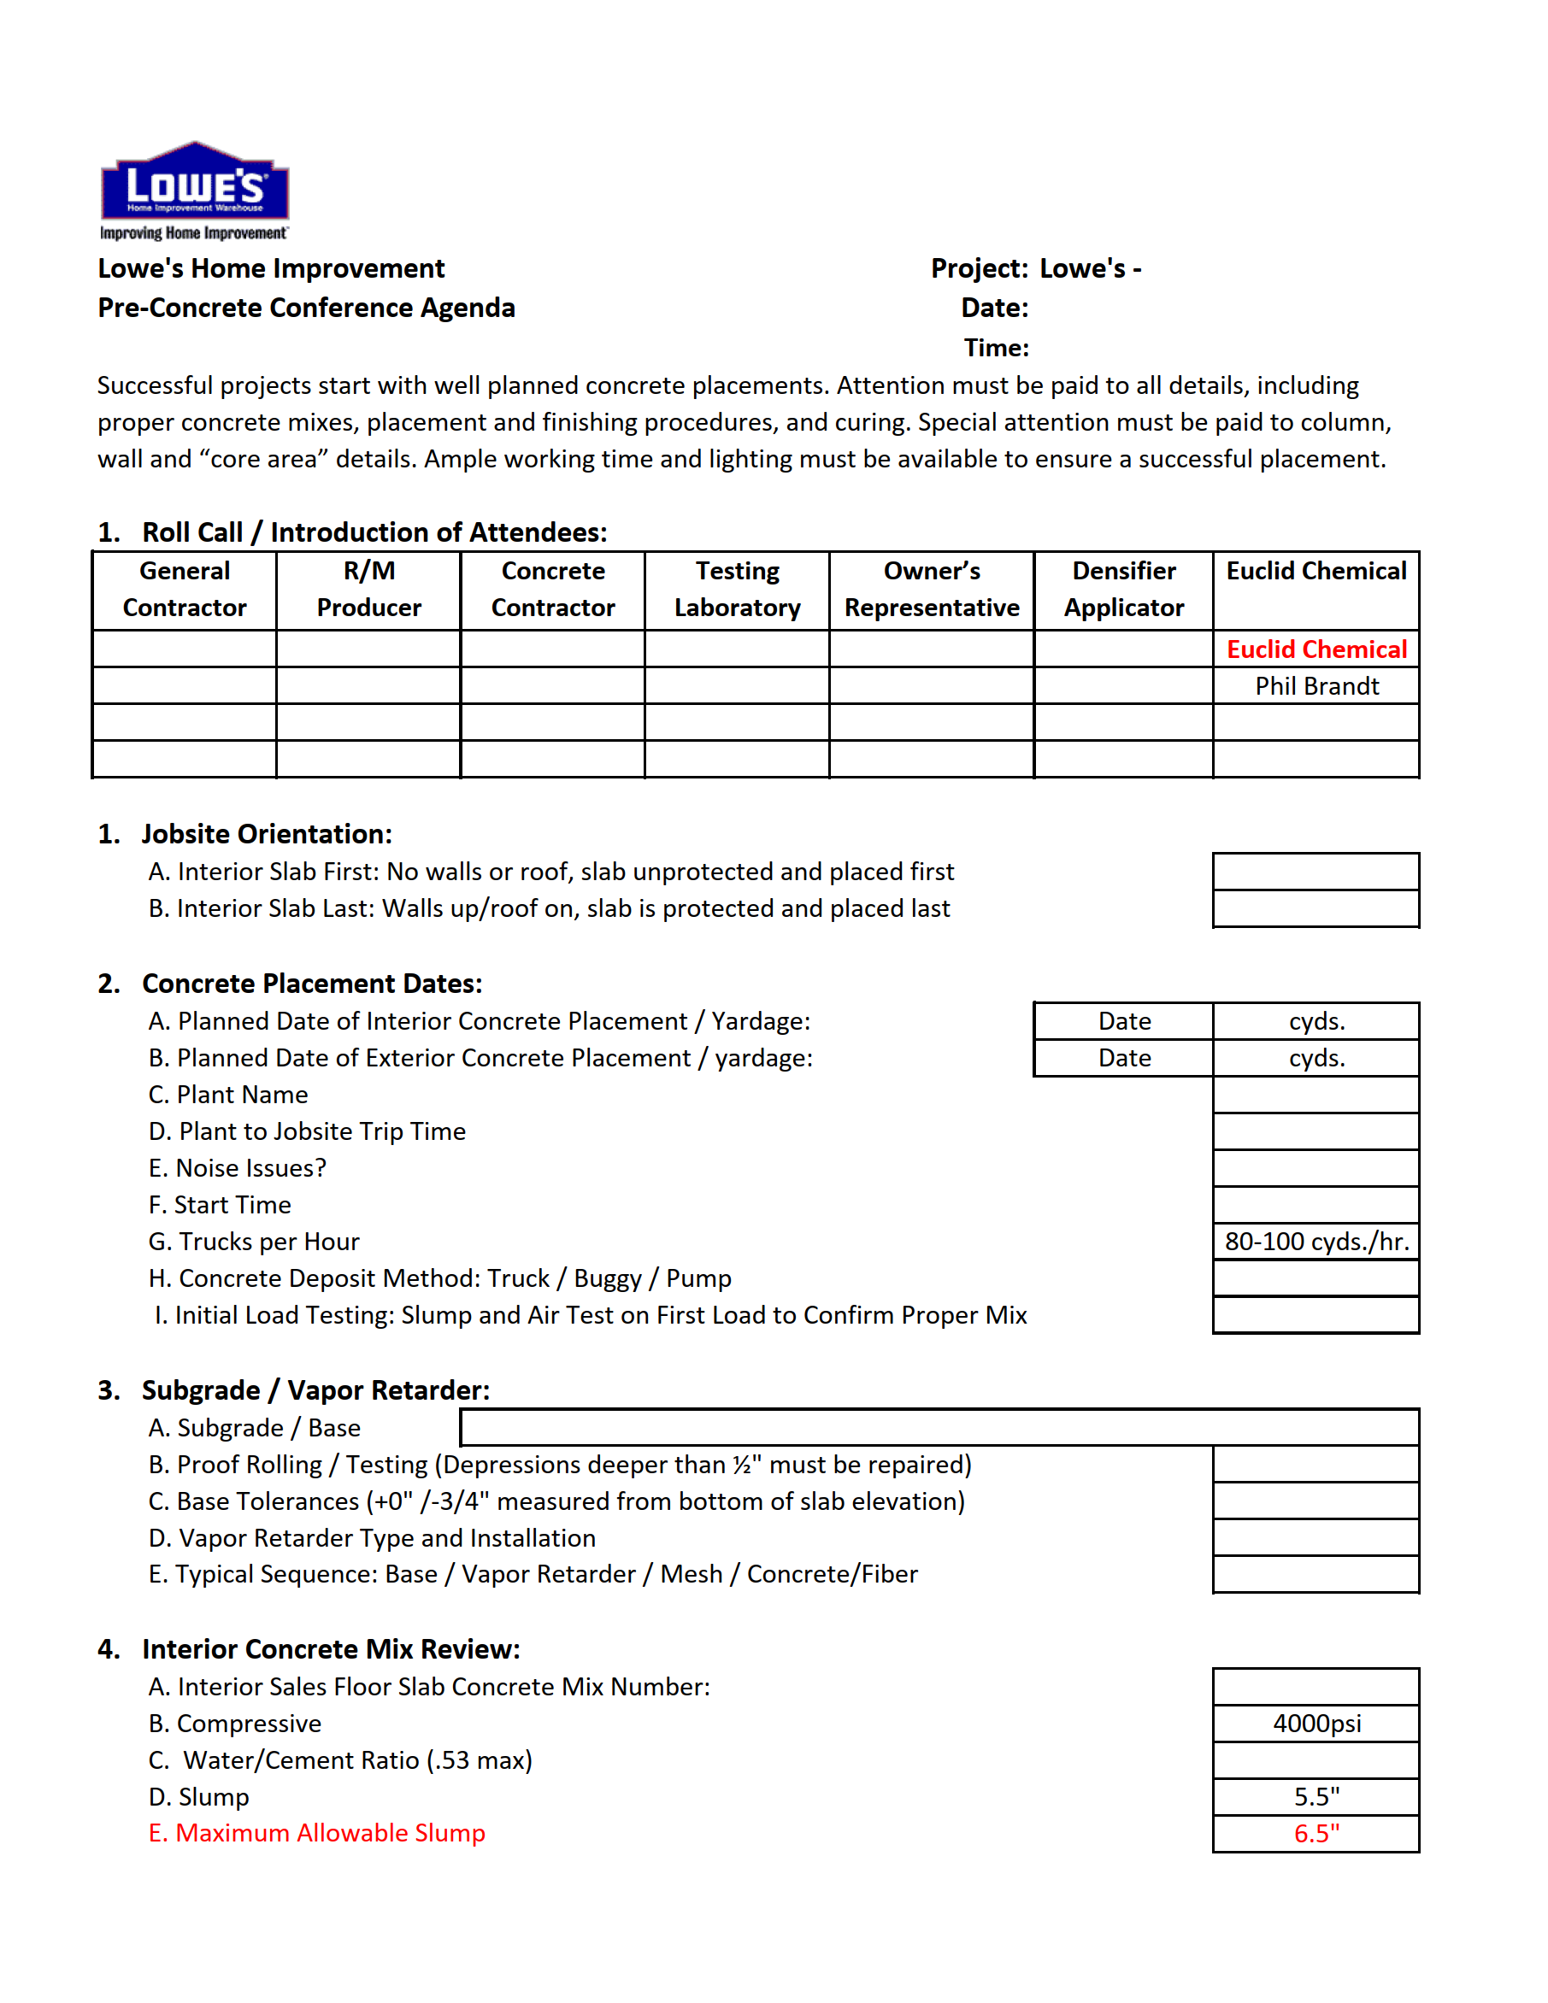

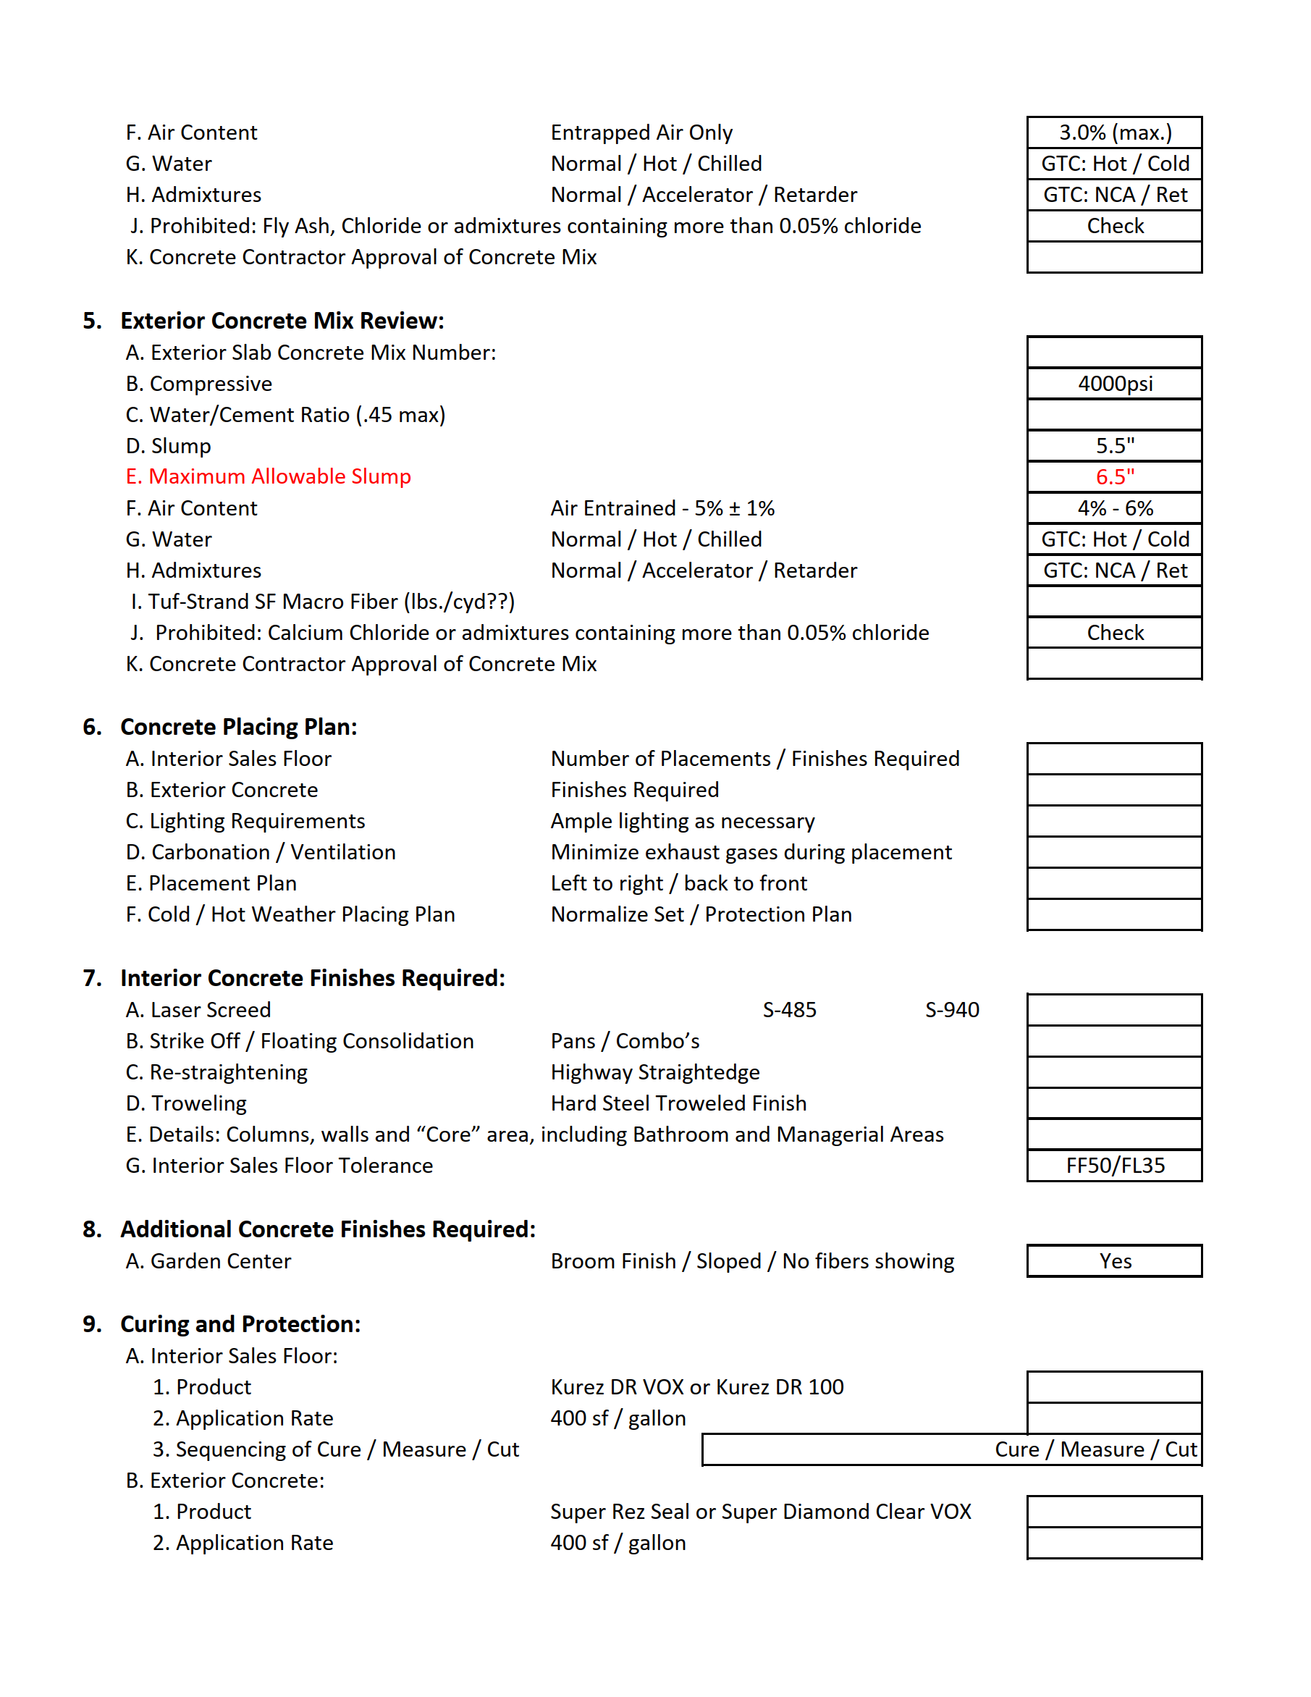

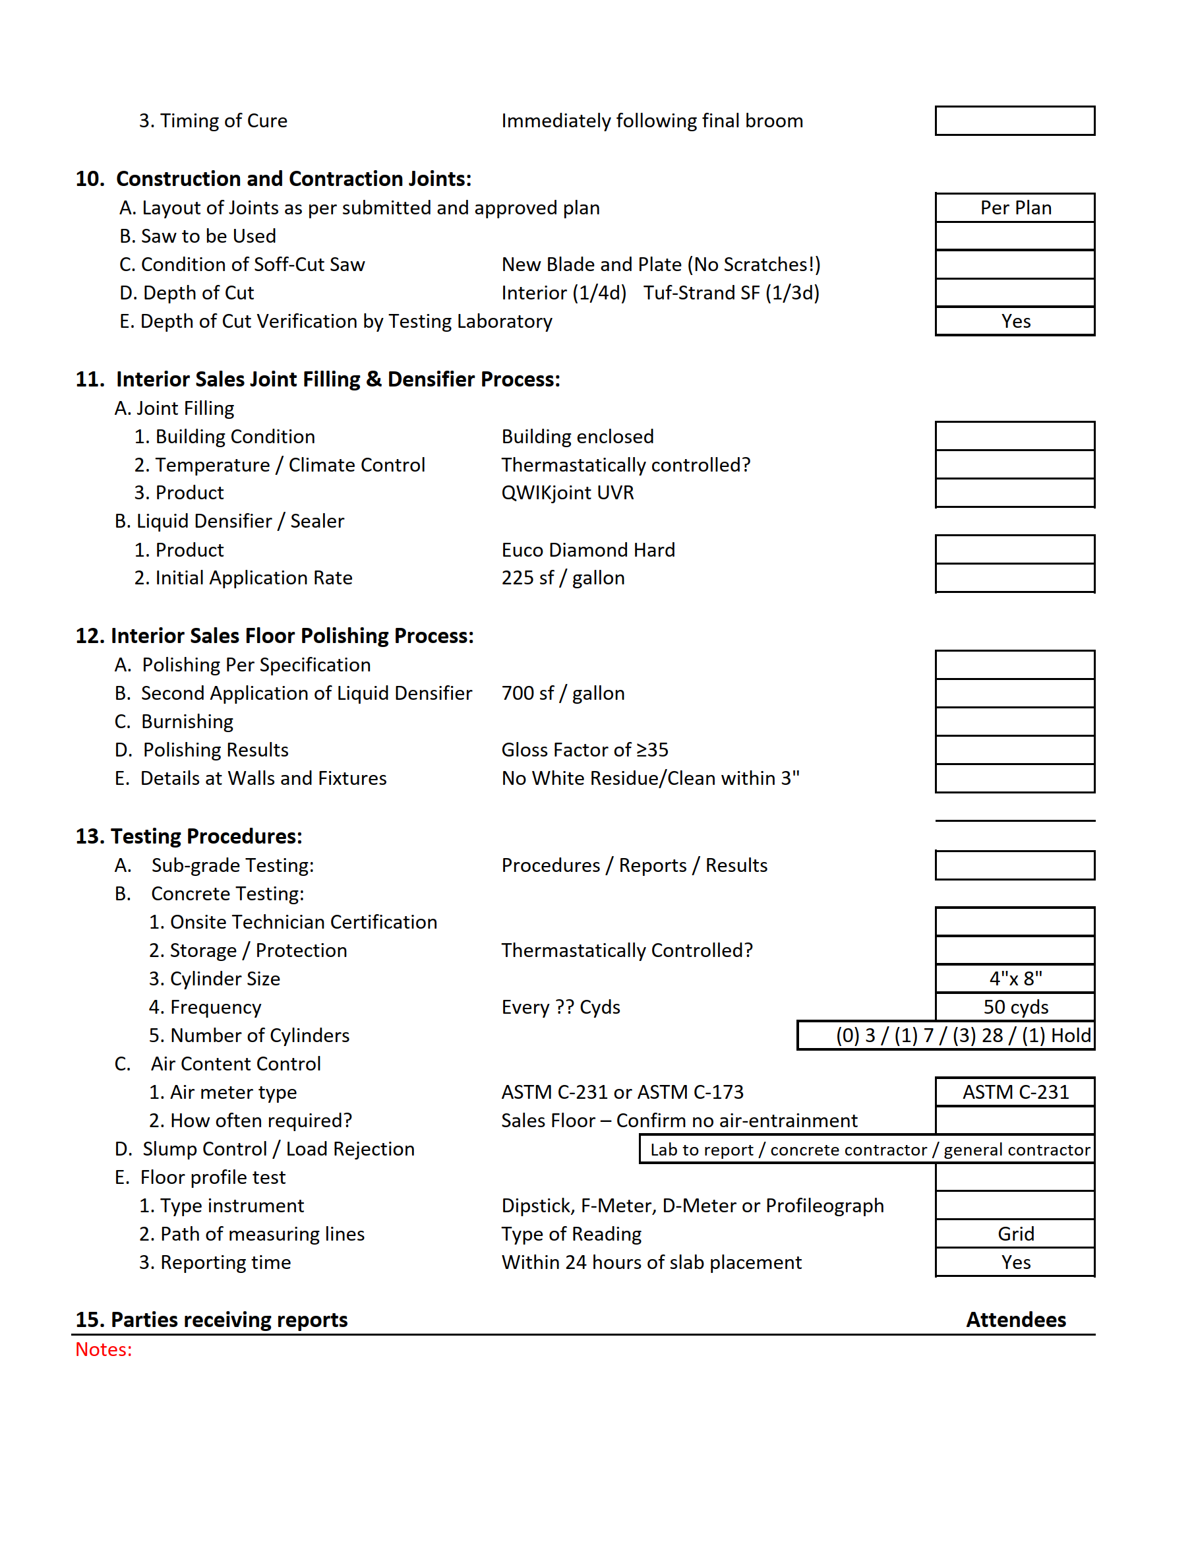

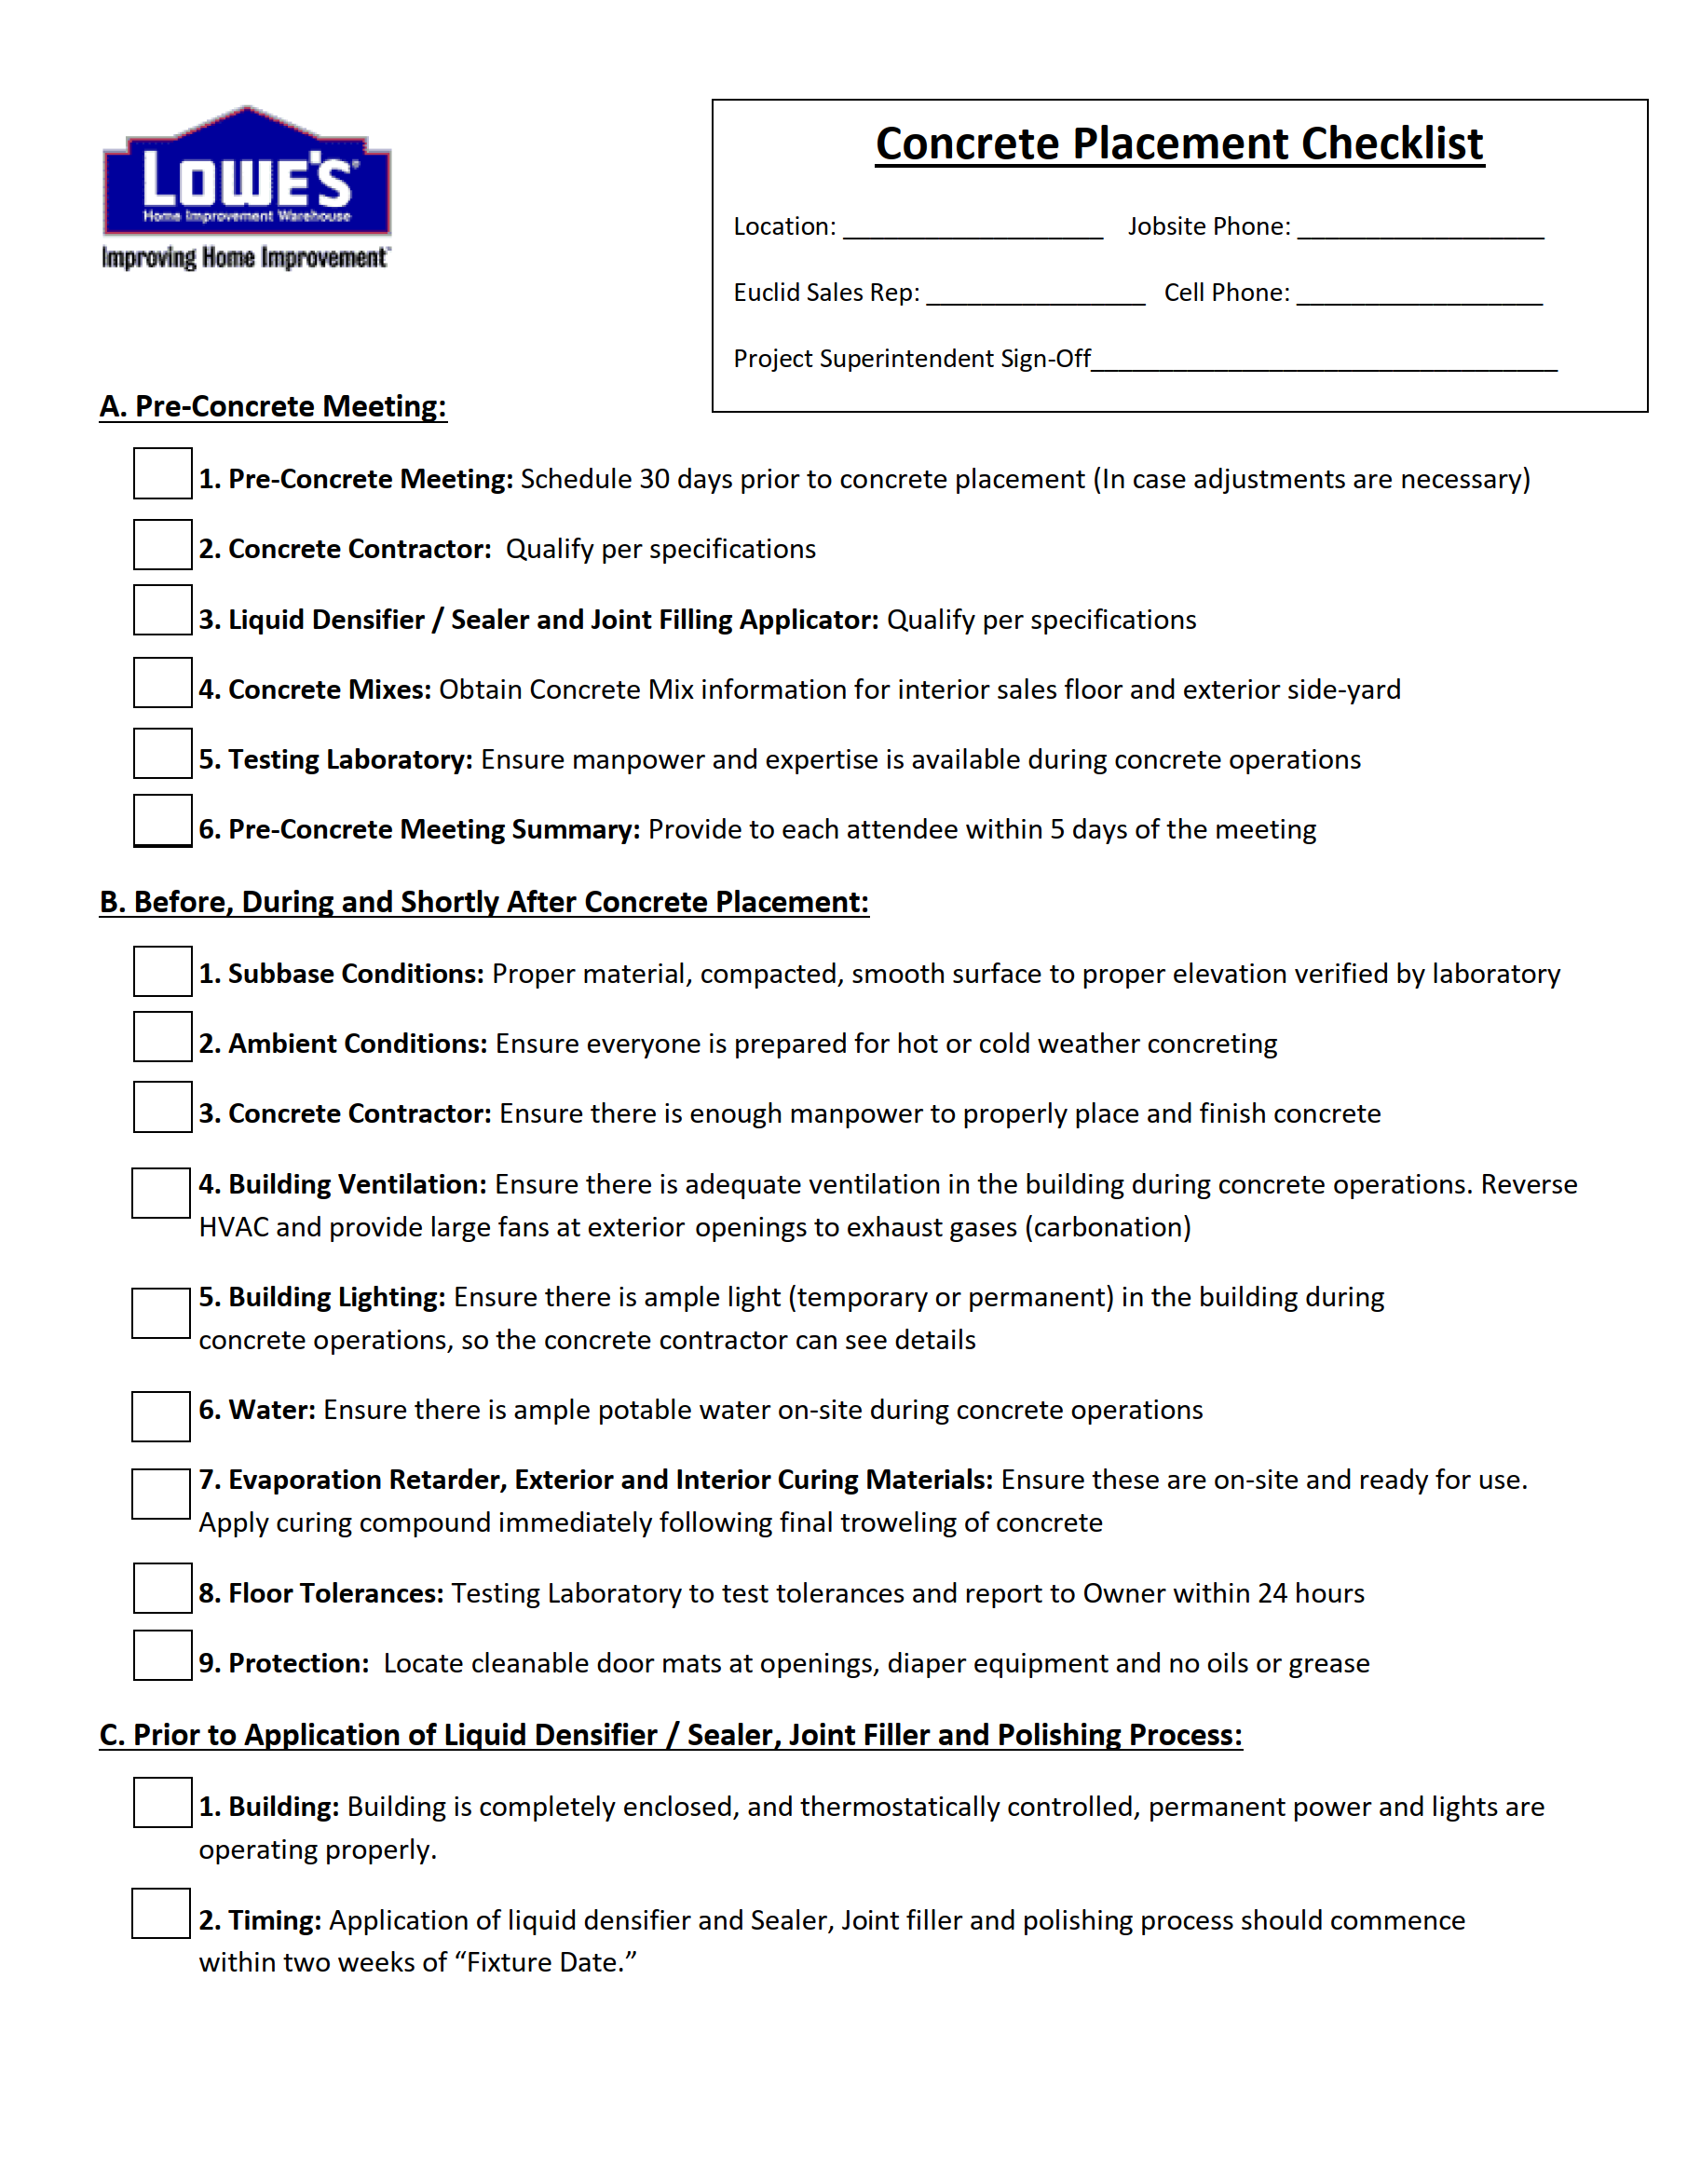

CONFORMANCE SUBMITTAL

Section 03300 – Cast in Place Concrete – Admixtures

Lowe’s of _____________________________________________________________________________
(City, State)

General Contractor: _____________________________________________________________________
(Company Name)

__________________________________________________________________
(Address, Phone Number)

Concrete Sub-Contractor: _________________________________________________________________
(Company Name)

__________________________________________________________________
(Address, Phone Number)

The following manufacturer has been selected (check box) for use in this project:

Concrete Admixture Manufacturers:

Euclid Chemical
Master Builders Solutions
Sika
GCP Applied Technologies

I represent to Lowe’s that the product selected will be installed in compliance with the applicable codes for the authorities having jurisdiction and in accordance with the project specification. If noncompliance is discovered the General Contractor shall make or cause to be made all necessary corrections to meet the applicable codes and specifications. Immediately or as directed by Lowe’s, the work shall be completed without additional cost to Lowe’s and / or the contract.

General Contractor: ________________________________________________________________
(Signature of the Authorized Agent of the General Contractor)

________________________________________________________________
(Print Name of the Authorized Agent of the General Contractor)

I represent to Lowe’s that the product selected will be installed in compliance with the applicable codes for the authorities having jurisdiction and in accordance with the project specification. If noncompliance is discovered the General Contractor shall make or cause to be made all necessary corrections to meet the applicable codes and specifications. Immediately or as directed by Lowe’s, the work shall be completed without additional cost to the Lowe’s and / or the contract.

Sub-Contractor: ________________________________________________________________
(Signature of the Authorized Agent of the Sub-Contractor)

____________________________________________________________________
(Print Name of the Authorized Agent of the Sub-Contractor)

CONFORMANCE SUBMITTAL

Section 03300 – Cast in Place Concrete – Interior Sales Floor Curing

Lowe’s of _______________________________________________________________________________
(City, State)

General Contractor: _______________________________________________________________________
(Company Name)

____________________________________________________________________
(Address, Phone Number)

Concrete Sub-Contractor: ____________________________________________________________________
(Company Name)

____________________________________________________________________
(Address, Phone Number)

The following product has been selected (check box) for use in this project from the list of acceptable products specified:

Moisture-Retaining Cover:

“HydraCure S16 or M5” by PNA Construction Technologies, Inc

“Transguard 4000” by REEF Industries

Spray Applied Curing Compound:

“Kurez DR VOX” or “Kurez DR100” by Euclid Chemical

I represent to Lowe’s that the product selected will be installed in compliance with the applicable codes for the authorities having jurisdiction and in accordance with the project specification. If noncompliance is discovered the General Contractor shall make or cause to be made all necessary corrections to meet the applicable codes and specifications. Immediately or as directed by Lowe’s, the work shall be completed without additional cost to Lowe’s and / or the contract.

General Contractor: ________________________________________________________________
(Signature of the Authorized Agent of the General Contractor)

____________________________________________________________________
(Print Name of the Authorized Agent of the General Contractor)

I represent to Lowe’s that the product selected will be installed in compliance with the applicable codes for the authorities having jurisdiction and in accordance with the project specification. If noncompliance is discovered the General Contractor shall make or cause to be made all necessary corrections to meet the applicable codes and specifications. Immediately or as directed by Lowe’s, the work shall be completed without additional cost to the Lowe’s and / or the contract.

Sub-Contractor: ________________________________________________________________
(Signature of the Authorized Agent of the Sub-Contractor)

________________________________________________________________
(Print Name of the Authorized Agent of the Sub-Contractor)

CONFORMANCE SUBMITTAL

Section 03300 – Cast in Place Concrete – Liquid Densifier/Sealer and Joint Filler

Lowe’s of _____________________________________________________________________________
(City, State)

General Contractor: _____________________________________________________________________
(Company Name)

__________________________________________________________________
(Address, Phone Number)

Concrete Sub-Contractor: __________________________________________________________________
(Company Name)

_______________________________________________________________
(Address, Phone Number)

The following product has been selected (check box) for use in this project from the list of approved manufacturers.

Specified Densifier/Sealer and Joint Filler:

“Euco Diamond Hard” by Euclid Chemical

“Euco QWIKjoint UVR” by Euclid Chemical

I represent to Lowe’s that the product selected will be installed in compliance with the applicable codes for the authorities having jurisdiction and in accordance with the project specification. If noncompliance is discovered the General Contractor shall make or cause to be made all necessary corrections to meet the applicable codes and specifications. Immediately or as directed by Lowe’s, the work shall be completed without additional cost to Lowe’s and / or the contract.

General Contractor: ________________________________________________________________
(Signature of the Authorized Agent of the General Contractor)

____________________________________________________________________
(Print Name of the Authorized Agent of the General Contractor)

I represent to Lowe’s that the product selected will be installed in compliance with the applicable codes for the authorities having jurisdiction and in accordance with the project specification. If noncompliance is discovered the General Contractor shall make or cause to be made all necessary corrections to meet the applicable codes and specifications. Immediately or as directed by Lowe’s, the work shall be completed without additional cost to the Lowe’s and / or the contract.

Sub-Contractor: ________________________________________________________________
(Signature of the Authorized Agent of the Sub-Contractor)

____________________________________________________________________
(Print Name of the Authorized Agent of the Sub-Contractor)

